**HIVE**

**Q.1**

**1**. **select a.name from airport a**

**join routes r1 on a.airport_id=r1.src_airport_id**

**Where a.airport_id=r1.src_airport_id and a.airport_id != r1.dest_airport_id limit 10;**

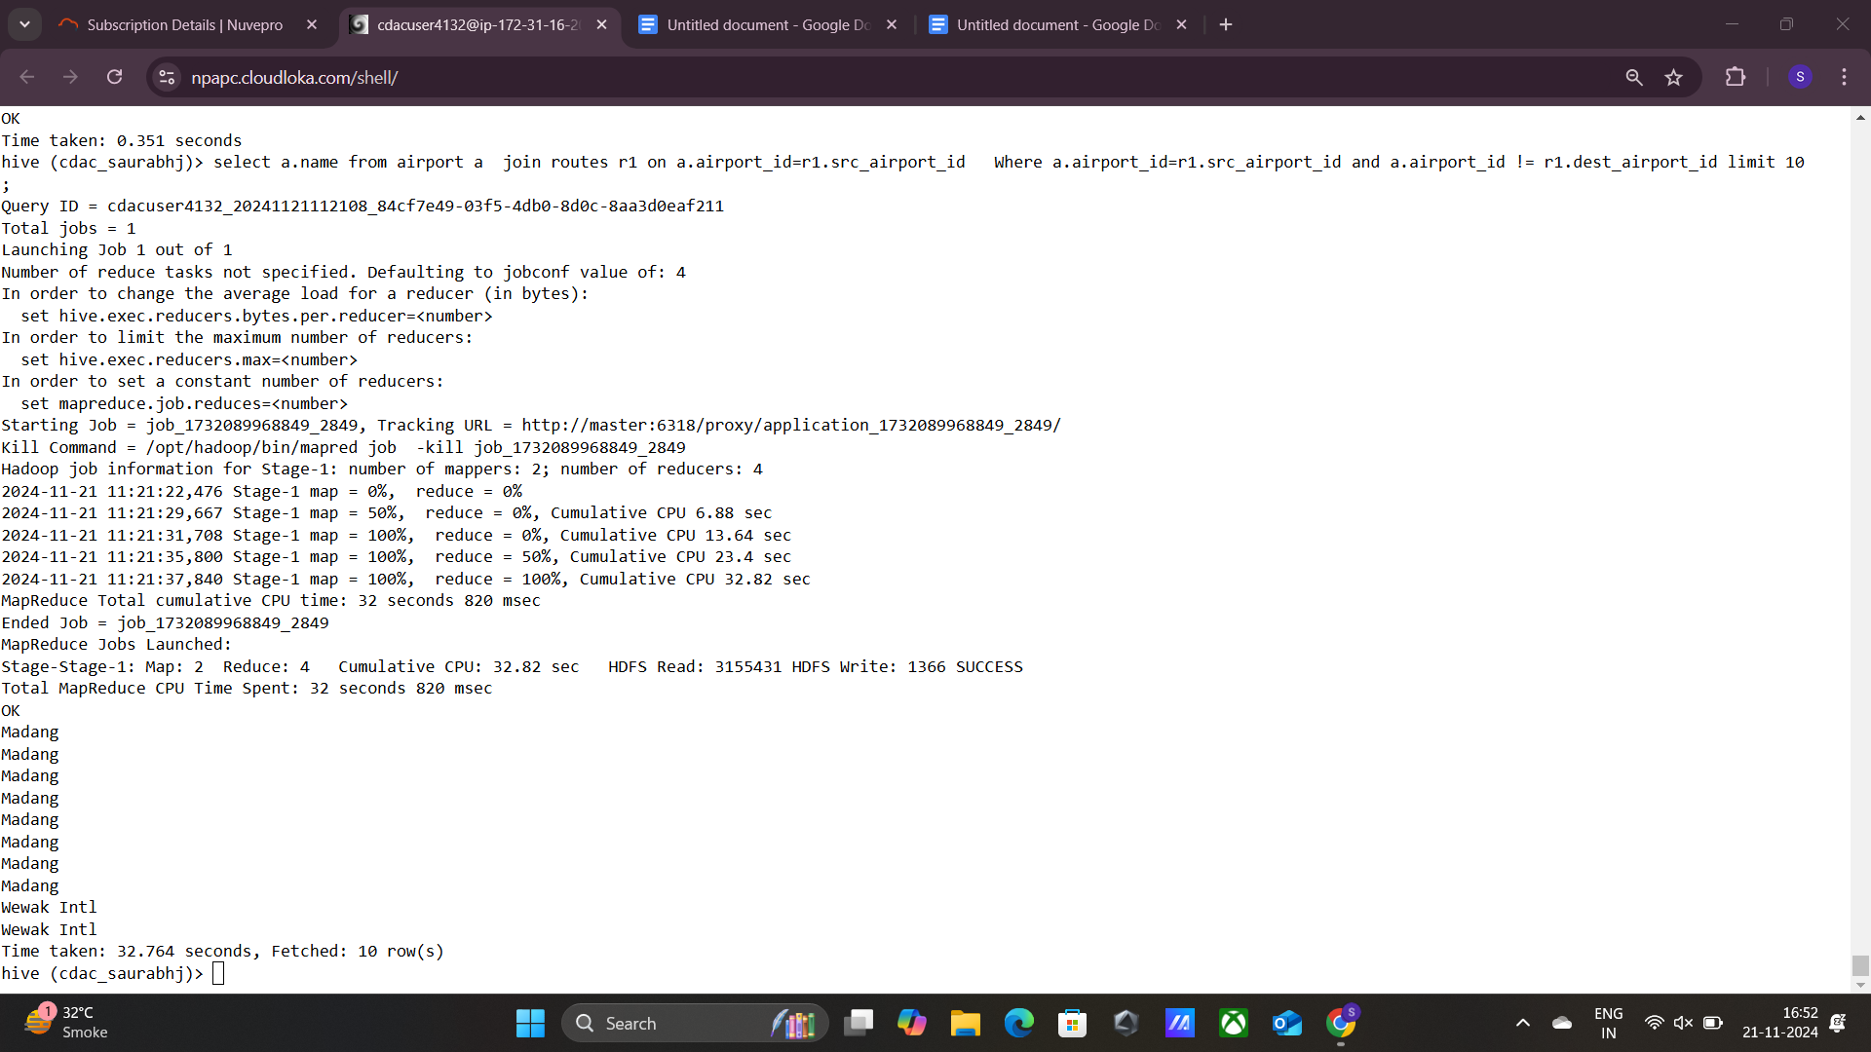

**2.**

Select al.name from airlines al

join routes r on al.airline_id=r.airline_id

Where count(al.name)> count(distinct r.airline_id)limit 10;

**3.**

**Select count(distinct (equipment)) from routes;**

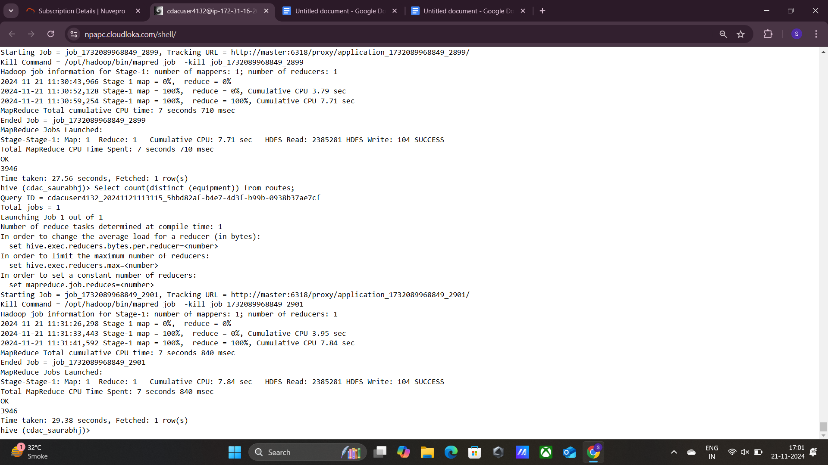

**Q.2**

**1.**

**Set hive.exec.dynamic.partition.mode=nonstrict;**

**Set hive.exec.dynamic.partition=true;**

**Create table routes_partitioned(airline string, airline_id int, src_airport_iata string, src_airport_id int, dest_airport_iata string, codeshare string, stops int, equipment string)**

**Partitioned by (dest_airport_id int)**

**Row format delimited**

**Fields terminated by ‘,’**

**Stored as textfile;**

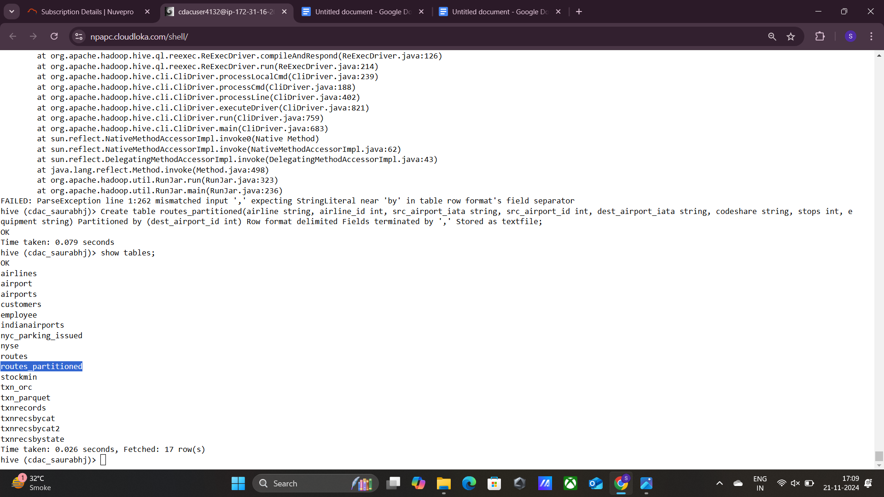

**2.**

**Insert overwrite table routes_partitioned partition(dest_airport_id) select airline, airline_id, src_airport_iata, src_airport_id, dest_airport_iata, codeshare, stops, equipment, dest_airport_id from routes;**

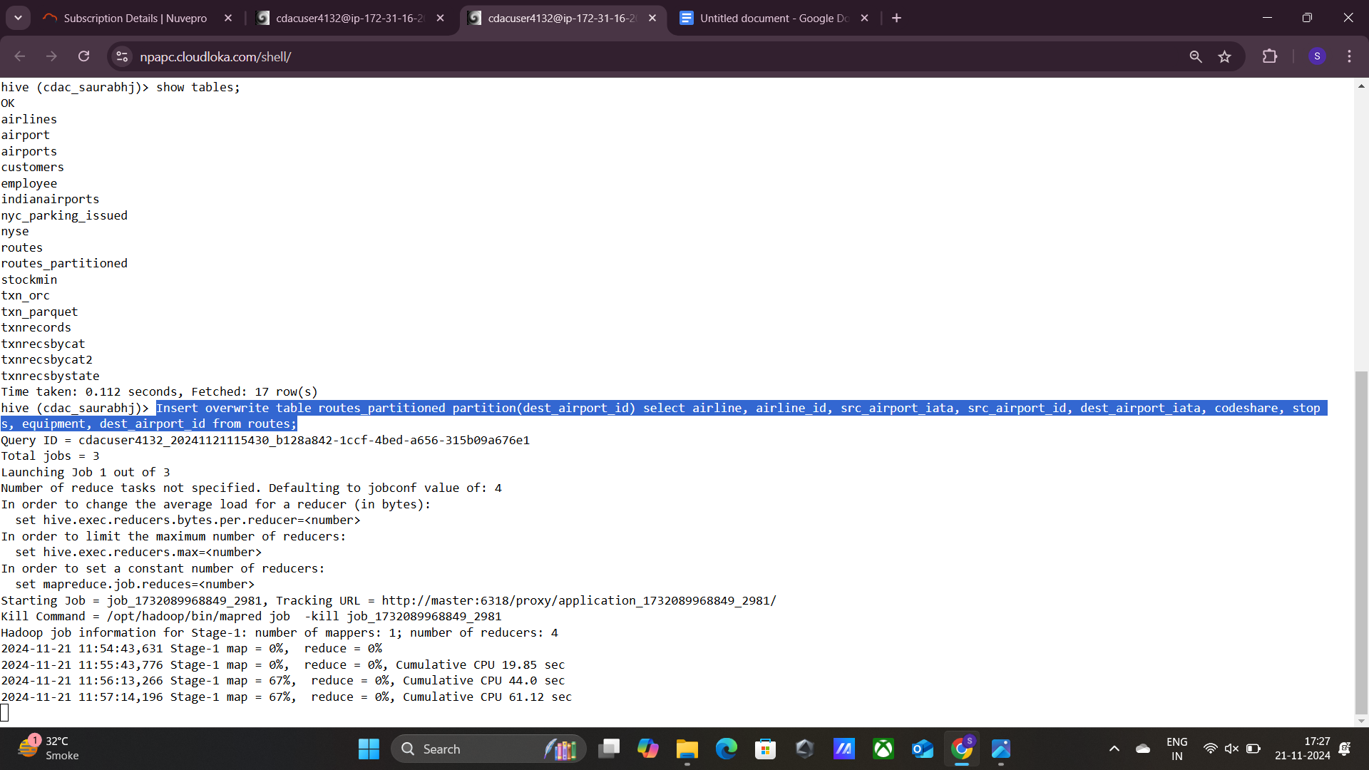

**3.**

**Select * from routes_partitioned where dest_airport_id =’ORD’ limit 10;**

**###*Last (insert) query didn’t run due to lag, can’t perform operations\***

**4.**

**SPARK**

**Q.2**

**#loading data..**

**from pyspark.sql.functions import sum,col,avg,max**

**df=spark.read.format("csv").option("header",True).option("inferSchema",True).load("/user/cdacuser4132/airlinesrdd")**

**1.**

**avg:**

**df.agg(avg('avg_rev_per_seat')).show()**



**Max:**

**df.select(['booked_seats']).orderBy('Year', ascending=True).show(1)**

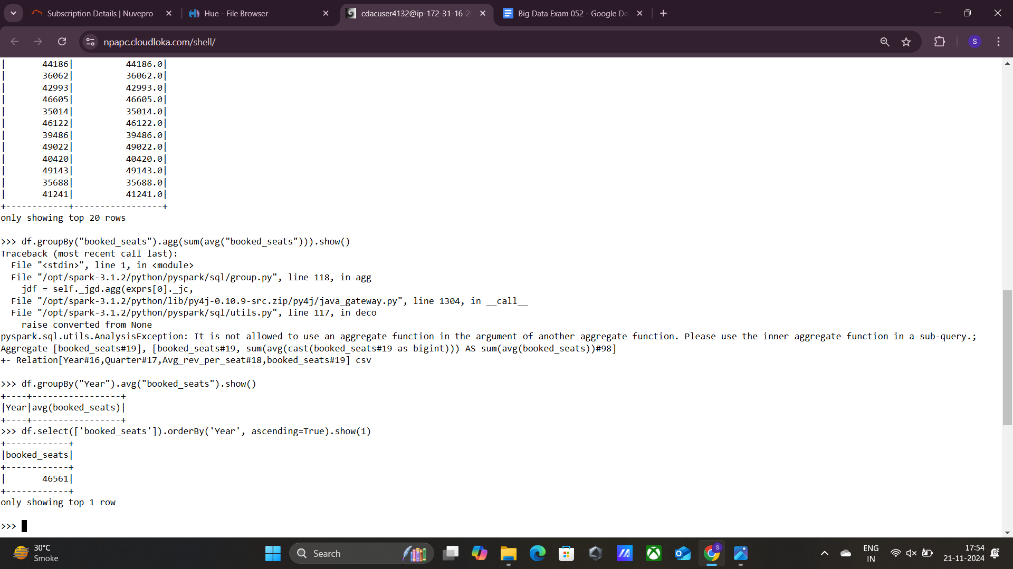

**Min:**

**df.select(['booked_seats']).orderBy('Year', ascending=False).show(1)**

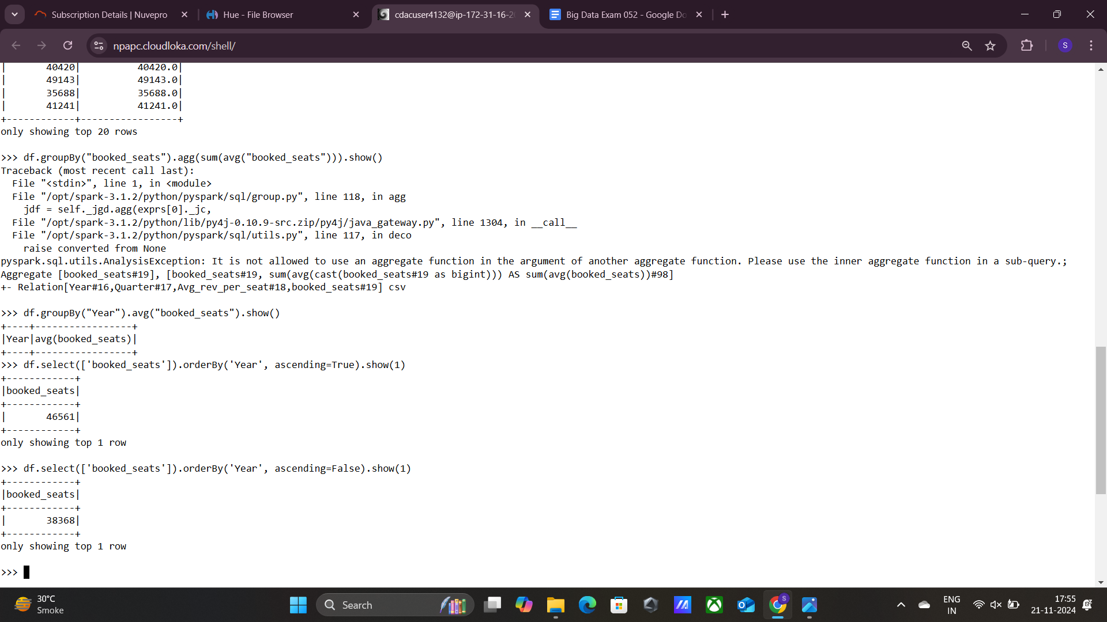

**3.**

**df.groupBy("Quarter").avg("booked_seats").show()**

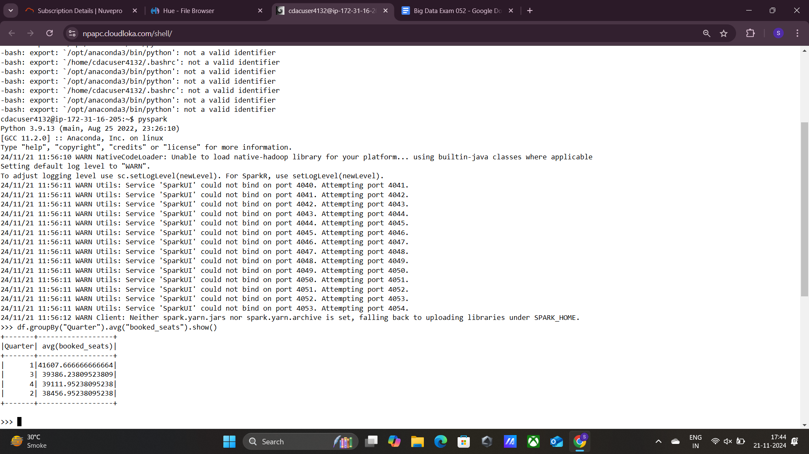

**5.**

**df.groupBy('Year','Quarter').agg(sum(col('avg_rev_per_seat')*col('booked_seats')).alias('Total_revenue')).orderBy('Total_revenue',ascending=False).show(1)**

